TASK1:

#include<windows.h>

#include <GL/glut.h>

void init(void)

{

glClearColor(1.0, 1.0, 1.0, 0.0); // Set display window colour to white

glMatrixMode(GL_PROJECTION); // Set projection parameters

gluOrtho2D(0.0, 35.0, 0.0, 30.0);

}

void drawShapes(void)

{

glClear(GL_COLOR_BUFFER_BIT); // Clear display window

//Set colour to black

glColor3f(0.0, 0.0, 0.0);

//Adjust the point size

glPointSize(10.0);

//Set colour to red

glColor3f(1.0, 0.0, 0.0);

// Draw a + sign outlined triangle

glBegin(GL_LINES);

// Draw a + sign outlined triangle

glVertex2i(10, 5);

glVertex2i(20, 5);

glVertex2i(15, 10);

glVertex2i(15,0);

glEnd();

glBegin(GL_LINES);

glColor3f(1.0, 0.0, 0.0);

glVertex2i(25, 15);

glVertex2i(30, 10);

glVertex2i(30, 15);

glVertex2i(25,10);

glEnd();

glBegin(GL_LINES);

glColor3f(1.0, 0.0, 0.0);

glVertex2i(5, 15);

glVertex2i(5, 23);

glVertex2i(15, 15);

glVertex2i(15,23);

glVertex2i(5, 15);

glVertex2i(15, 15);

glVertex2i(5, 23);

glVertex2i(15,23);

glVertex2i(5, 20);

glVertex2i(15,20);

glVertex2i(5, 20);

glVertex2i(10,23);

glVertex2i(10, 23);

glVertex2i(15,20);

glVertex2i(9, 15);

glVertex2i(9,19);

glVertex2i(11, 15);

glVertex2i(11,19);

glVertex2i(9, 19);

glVertex2i(11,19);

glEnd();

glFlush(); // Process all OpenGL routines

}

int main(int argc, char* argv[])

{

glutInit(&argc, argv); // Initalise GLUT

glutInitDisplayMode(GLUT_SINGLE|GLUT_RGB); // Set display mode

glutInitWindowPosition(50, 100); // Set window position

glutInitWindowSize(400, 300); // Set window size

glutCreateWindow("An Example OpenGL Program"); // Create display window

init(); // Execute initialisation procedure

glutDisplayFunc(drawShapes); // Send graphics to display window

glutMainLoop(); // Display everything and wait

return 0;

}

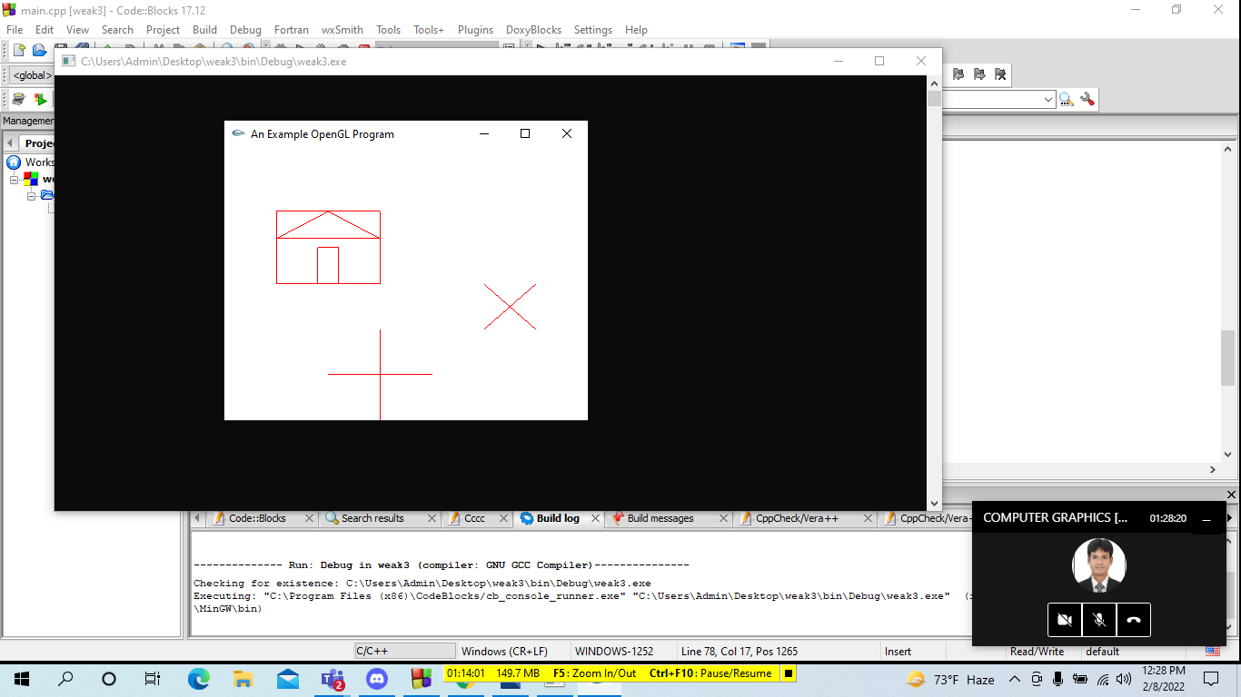

TASK3:

#include <GL/gl.h>

#include <GL/glut.h>

void display(void)

{

glClear (GL_COLOR_BUFFER_BIT);

glColor3f (1.0, 0.0, 1.0);

glBegin(GL_QUADS);

glVertex3f(0.05f, 0.05f, 0.0f);

glVertex3f(0.35f, 0.05f, 0.0f);

glVertex3f(0.40f, 0.35f, 0.0f);

glVertex3f(0.00f, 0.35f, 0.0f);

glEnd();

glColor3f (1.0, 1.0, 1.0);

glColor3f (0.0, 0.0, 1.0);

glBegin(GL_TRIANGLES);

glVertex3f(0.5f, 0.05f, 0.0f);

glVertex3f(0.75f, 0.05f, 0.0f);

glVertex3f(0.5f, 0.35f, 0.0f);

glEnd();

glColor3f (1.0, 1.0, 0.0);

glBegin(GL_TRIANGLES);

glVertex3f(0.5f, 0.35f, 0.0f);

glVertex3f(0.75f, 0.05f, 0.0f);

glVertex3f(0.75f, 0.35f, 0.0f);

glEnd();

glColor3f (1.0, 0.0, 0.0);

glBegin(GL_TRIANGLES);

glVertex3f(0.5f, 0.35f, 0.0f);

glVertex3f(0.75f, 0.35f, 0.0f);

glVertex3f(0.63f, 0.50f, 0.0f);

glEnd();

glFlush ();

}

void init (void)

{

/* select clearing (background) color */

glClearColor (0.0, 0.0, 0.0, 0.0);

/* initialize viewing values */

glMatrixMode(GL_PROJECTION);

glLoadIdentity();

glOrtho(0.0, 1.0, 0.0, 1.0, -10.0, 10.0);

}

int main(int argc, char** argv)

{

glutInit(&argc, argv);

glutInitDisplayMode (GLUT_SINGLE | GLUT_RGB);

glutInitWindowSize (600, 600);

glutInitWindowPosition (100, 100);

glutCreateWindow ("MD AL; AMIN CHOWDHURY");

init ();

glutDisplayFunc(display);

glutMainLoop();

return 0;

}

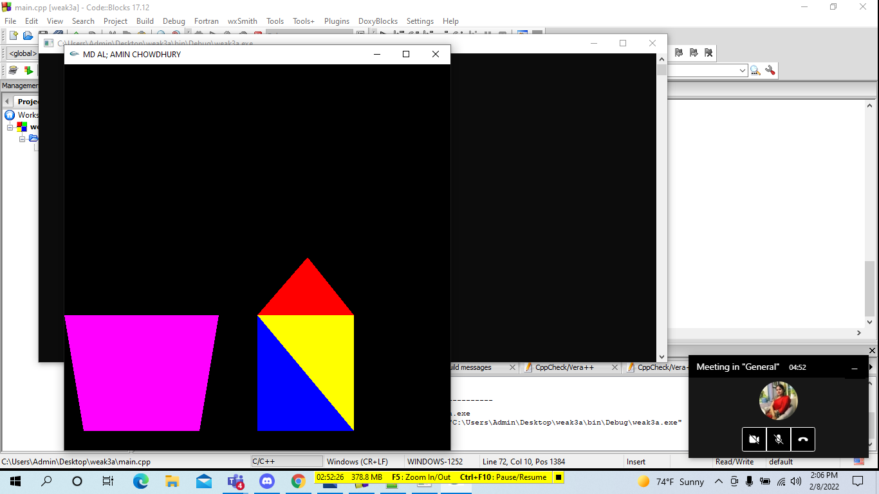

TASK3:

#include<windows.h>

#include <GL/glut.h>

void init(void)

{

glClearColor(1.0, 1.0, 1.0, 0.0); // Set display window colour to white

glMatrixMode(GL_PROJECTION); // Set projection parameters

gluOrtho2D(0.0, 35.0, 0.0, 30.0);

}

void drawShapes(void)

{

glClear(GL_COLOR_BUFFER_BIT); // Clear display window

//Set colour to black

glColor3f(0.0, 0.0, 0.0);

//Adjust the point size

glPointSize(10.0);

//Set colour to red

glColor3f(1.0, 0.0, 0.0);

// Draw a + sign outlined triangle

glBegin(GL_TRIANGLES); //Begin triangle coordinates

//Triangle

glColor3f (0.0, 1.5, 1.0);

glVertex2i(5, 20);

glVertex2i(25,20);

glVertex2i(15,29);

glEnd();

glBegin(GL_QUADS);

glColor3f (0.0, 0.5, 1.0);

glVertex2i(5,5);

glVertex2i(25,5);

glVertex2i(25,20);

glVertex2i(5,20);

glColor3f (1.0,0.0, 0.2);

glVertex2i(13,5);

glVertex2i(17,5);

glVertex2i(17,15);

glVertex2i(13,15);

glColor3f (0.9,1.0, 0.2);

glVertex2i(8,10);

glVertex2i(10,10);

glVertex2i(10,12);

glVertex2i(8,12);

glColor3f (0.9,1.0, 0.2);

glVertex2i(22,10);

glVertex2i(20,10);

glVertex2i(20,12);

glVertex2i(22,12);

glEnd();

glFlush(); // Process all OpenGL routines

}

int main(int argc, char* argv[])

{

glutInit(&argc, argv); // Initalise GLUT

glutInitDisplayMode(GLUT_SINGLE|GLUT_RGB); // Set display mode

glutInitWindowPosition(50, 100); // Set window position

glutInitWindowSize(800, 600); // Set window size

glutCreateWindow("MD AL AMIN CHOWDHURY"); // Create display window

init(); // Execute initialisation procedure

glutDisplayFunc(drawShapes); // Send graphics to display window

glutMainLoop(); // Display everything and wait

return 0;

}

